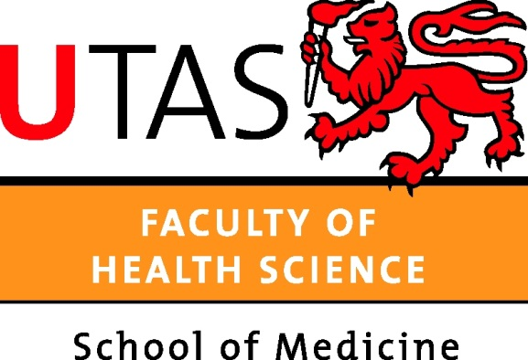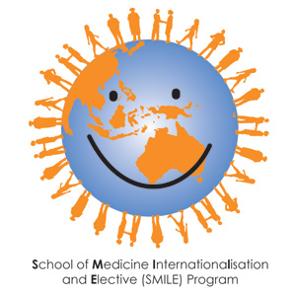

Criteria for achieving a School of Medicine- Global Health Award
The School of Medicine supports all medical students to achieve skills in global health. The aim is to produce global citizens capable of practising anywhere in the world. The MBBS curriculum provides a basic introduction to global health. However, some students may wish to pursue more in depth training in global health and want to achieve recognition for this special interest.
A Global Health ‘Award’, has been developed by the School of Medicine, in recognition of interest and commitment towards global health. It consists of a ‘certificate of accomplishment’ acknowledging that a student has participated in a range of additional activities associated with global health. Points can be scored for various activities (see below). The Award will be a non- credentialed ‘certificate’ signed by the Director of Electives & Internationalisation and given before the final exam in 5th year- so it can be added to the student’s portfolio.
Total points required 100
Activity | Details | Points | Comments
Joining global health related club or society | Member of IMPACT | 20 | Add 30 points if you are an office bearer
 | Member of ISSUE | 20
 | Member of vGen | 20
Selective | Selective in global health in 5th yr HCS | 50
Overseas travel | Elective | 30
 | Summer volunteer activity | 30
Attendance at relevant lectures or courses | Attendance at Global Health lecture series at the RCS or LCS | 40
 | Participation in a global health MOOC | 50
 | Attendance at relevant global health conference | 40
 | IMPACT Lecture series (4 lectures) | 40
 | Red Cross International Humanitarian Law Workshop | 40
 | Inter-cultural Peer e-Learning in Global Health | 40
Research | Research project on global health issue | 50
Service | Visiting student buddy | 30
 | Fund raising for overseas aid | 10
 | Active participation in relevant NGO eg Red Cross, Oaktree, Lantang Valley health Centre., Peter Hewitt Foundation | 30
Other | Any other global health related activity |  | Points to be negotiated

Application Form: School of Medicine Global Health Award

Date:
Name:
Email:
Mail address:
Current year of study:

Points applied for:
Activity | Points
Total

Signed :

Send to : Director of Electives & Internationalisation (or email: nick.cooling@utas.edu.au)

