Global Health Award &
Global Health Deed of Accomplishment

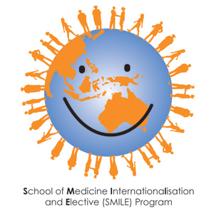

Premable
The School of Medicine encourages and supports all medical students to achieve skills in global health. The School aspires to produce high quality global citizens capable of practising anywhere in the world. While the MBBS curriculum provides a sound introduction to global health, some students may wish to pursue more in depth training in global health, through co-curricular activities and desire to achieve recognition for this special interest.
Deed of Accomplishment
A Global Health ‘Deed of Accomplishment” has been developed by the SMILE Program within the School of Medicine, in recognition of interest and commitment towards global health. The deed acknowledges that a student has participated in a range of additional activities associated with global health. Points can be scored for various activities (see below) and a minimum of 200 points is deemed to indicate sufficient commitment towards global health to achieve the deed. The non- credentialed ‘certificate’ is signed by the Director of Electives & Internationalisation and Lecturer in Global Health and given to the student any time (once 100 points have accumulated) before the final exam in 5th year- so it can be added to the student’s portfolio.
Global health Award
For the student who accumulates the highest score in global health related activities by 5th yr there will be a Global Health Award. This is to be presented as a book prize at the Declaration of Geneva and Prize Giving ceremony.

Criteria
Total points required 200
Activity | Details | Points | Comments
Joining global health related club or society | Member of IMPACT | 20 | Add 30 points if you are an office bearer
 | Member of ISSUE | 5 points per year | Max 20 points
 | Member of vGen | 5 points per year | Max 20 points
Selective | Selective in global health in 5th yr HCS | 50
Overseas travel | Elective | 30
 | Summer volunteer activity | 30
Attendance at relevant lectures or courses | Attendance at Global Health lecture series at the RCS or LCS | 40
 | Participation in a global health MOOC | 50
 | Attendance at relevant global health conference | 40
 | IMPACT Lecture series (4 lectures) | 10 points per lecture | Max 40 points
 | Red Cross International Humanitarian Law Workshop | 40
 | Inter-cultural Peer e-Learning in Global Health (RIPPLE) | 40
Research | Research project on global health issue | 50
Service | Visiting student buddy or VISA | 10 points per year | Max 30 points
 | Fund raising for overseas aid | 10
 | Active participation in relevant NGO eg Red Cross, Oaktree, Lantang Valley health Centre., Peter Hewitt Foundation | 30
Other | Any other global health related activity |  | Points to be negotiated

Other activities where points are applied for:
Activity | Points
Total

Application Form: School of Medicine Global Health Award

Date:
Name:
Email:
Mail address:
Current year of study:

Signed :

Send to : Director of Electives & Internationalisation (or email: nick.cooling@utas.edu.au)

