Should Tasmania Introduce Notional Estate Laws?

Final Report
September 2019

How to use this paper

This paper is written in an easy to read way.
We use pictures to explain some ideas.

Some words are written in blue. We explain what these words mean.
This is a hard paper to understand.
You can ask someone to help you read it.
Maybe a friend, family member, support person or advocate.

This easy read paper is a short version of a bigger paper.
You can find our bigger paper on our website at
https://www.utas.edu.au/law-reform/publications/completed-law-reform-projects

What is this paper about?

The Tasmania Law Reform Institute makes sure laws are fair, up-to-date and work well for the community.

In this paper when we say we, it means the Tasmania Law Reform Institute.
In March 2019 we wrote a paper called
Should Tasmania Introduce Notional Estate Laws?

It looked at the laws in other parts of Australia and other countries.

We asked Tasmanians questions to get their ideas.

This easy read booklet explains what we think the Tasmanian Government should do about notional estates.

Should Tasmania introduce notional estate laws?

We asked people if Tasmania needs a new law about
- people’s estates and

- what family members can claim when someone dies

estates are the money and things owned by someone when they die.

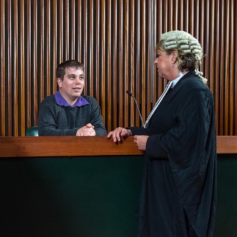
claim is when a person asks the Supreme Court for more from a family member’s estate.

Notional estate can include

- gifts made to someone in the three years before death

- property the person who died owned with other people

- life insurance

- superannuation.

They are assets that are not part of a person’s estate

This means they can not be part of a claim by family members.

Notional estate laws allow a judge to say these assets are part of an estate.

Then family members can claim a share of them.

We wanted to find out if Tasmania should have notional estate laws.

People said different things
- Some thought it was a good idea

- Most people thought it was not a good idea.

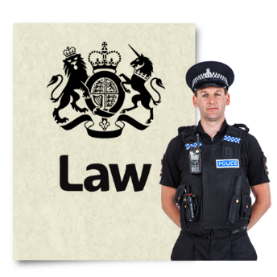
We recommend that the Tasmanian government should not change the law unless all of Australia does

recommend is when you suggest what should or should not happen.

Why there shouldn’t be Notional Estate Laws in Tasmania

The main reasons we say there should not be notional estate laws in Tasmania now, are:

- There is not enough proof that changing the law would make things better.

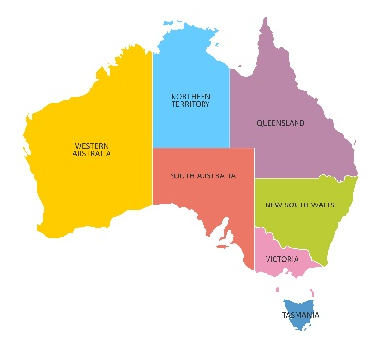
- Changing the law may not help because the law is different around Australia.

If people want to avoid claims they could because the law is different in other States.

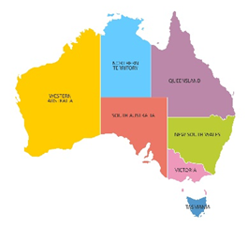
- New South Wales is the only place in Australia that has these laws.

There is not enough proof that NSW law is working ok.

- If we change the law, it would affect a lot of people.
It could be slower and cost more to sort out a claim.

- Sometimes there are ways people can claim assets without notional estate laws.

For example
Jim worked on his Dad’s farm for no pay. He said he would have the farm when he died.
To make things fair, Jim can ask the court for the farm.

In the future
Australians should decide if they want the same notional estate law all around Australia.

More work needs to be done to see:
- if notional estate law is working in New South Wales
- if notional estate law is needed
- what Australians think about notional estate law.

If there are changes, there should be
information and education for the community

- people will need to know about it and what it means.

Families should be able to agree that they will not make a claim
For example
Jim’s Dad wants to transfer the farm to him. If the rest of the family and the court say it is ok, they cannot try to claim the farm after Dad dies.

This easy read document was created by
Speak Out Association of Tasmania.
We use photosymbols®
stock and custom images.
For information on easy read email:
burnie@speakoutadvocacy.org

