Disability Inclusion Action Plan 2022-2024
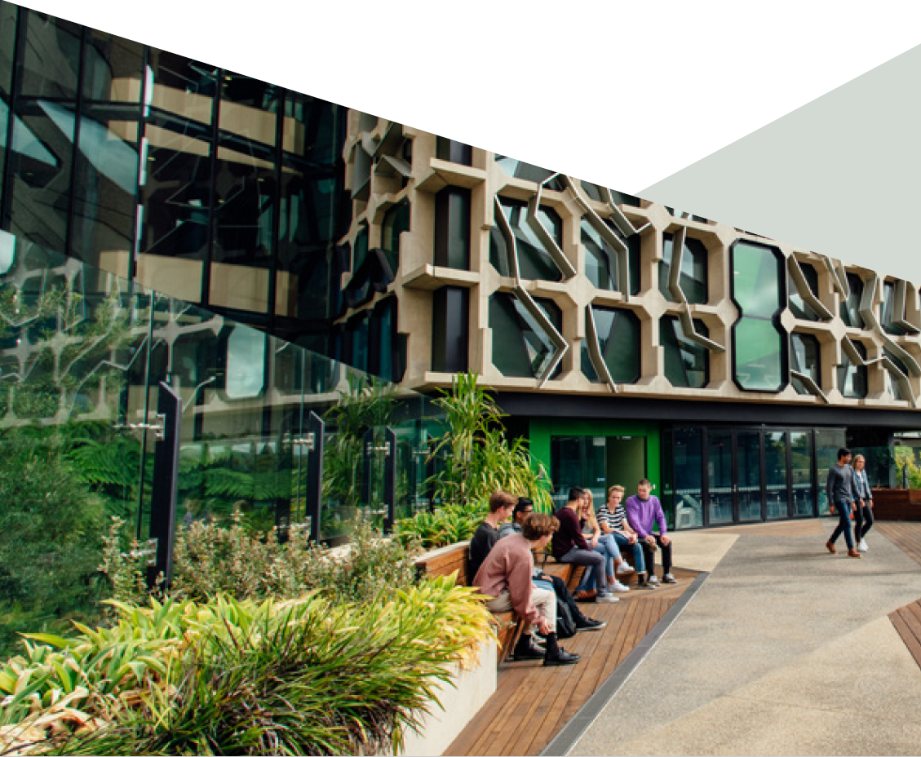
Contents
A word from the Provost 2
Legislative context 3
What is disability? 3
Supporting students and staff with disability 3
Development of the Disability Inclusion Action Plan 4
Progress and reporting on the Plan 4
1. Priority area: Learning and teaching 5
2. Priority area: Digital and online environment 6
3. Priority area: Employment 7
4. Priority area: Leadership and capability building 9
5. Priority area: Inclusive campus 11

A word from the Provost
The University of Tasmania acknowledges and celebrates that people with disability are part of our University community as students, staff, residents, visitors and through our activities in learning and teaching, research, and community engagement.
We are committed to being inclusive and responsive to the needs of people with disability, and to creating diverse, inclusive, and accessible educational experiences and environments to which people with disability feel a sense of belonging and connection. We recognise that inclusion encompasses a wide range of initiatives that enable equitable participation in University life and activities.
We are committed to being people-centric and respectful, and support increasing diversity, as expressed in our Statement of Values, Strategic Plan, People Strategy, Workplace Diversity and Inclusion Strategy and People Policy principles.
As Provost, I am the Executive Sponsor of the University’s Disability Inclusion Action Plan and provide senior leadership for targeted actions to improve the University’s practices and the experiences of University community members with disability, and to remove barriers to their full participation in University activities.
Professor Jane Long

Legislative context
- Disability Discrimination Act 1992 (Cth) – the Act provides protection to people with disability by making it unlawful to discriminate against a person on the grounds of their disability. Higher education institutions must provide services and facilities in such a way as to ensure students and staff with disability can participate on the same basis as those without and, if required, make reasonable adjustments to facilitate participation. - https://www.legislation.gov.au/Details/C2018C00125
- Disability Standards for Education 2005 (Cth) – the Standards specify how education and training are to be made accessible to students with disabilities and cover enrolment; participation; curriculum development, accreditation, and delivery; student support services; and elimination of harassment and victimisation - https://www.legislation.gov.au/Details/F2005L00767
- Anti-Discrimination Act 1998 (Tas) – the Act prohibits discrimination and provides for investigation, conciliation, and inquiry into complaints in relation to discrimination - https://www.legislation.tas.gov.au/view/html/inforce/current/act-1998-046
Resources developed that support the intent of the legislation include:
- Australian University Mental Health Framework – provides guidance for mentally healthy university settings that support students to thrive - https://www.orygen.org.au/Policy/University-Mental-Health-Framework/Framework/
- United Nations Convention on the Rights of Persons with Disabilities (CRPD) - the Convention is intended as a human rights instrument with an explicit, social development dimension. It adopts a broad categorisation of persons with disability and reaffirms that all persons with all types of disability must enjoy all human rights and fundamental freedoms. Australia is one of the 96 countries that has ratified the Convention - http://www.un.org/development/desa/disabilities/convention-on-the-rights-of-persons-with-disabilities.html
- Web Content Accessibility Guidelines (WCAG) – how to make web content more accessible to people with disability- - https://www.w3.org/WAI/standards-guidelines/wcag/

What is disability?
Disability is a complex experience that reflects the interaction between people and the society in which they live. Disability may be physical, mental, intellectual, neurological, or sensory, and can be permanent or temporary.
Overcoming the difficulties faced by people with disability requires interventions to remove environmental and social barriers.

Supporting students and staff with disability
The University encourages students and staff to participate and succeed in all aspects of University life and provides focused support for students and staff with disability.
The Disability Standards for Education 2005 require the University to establish that any course participation requirement is essential for the achievement of the learning outcomes of a course, and to commit to making reasonable adjustments to enable someone with disability to participate in the learning experience (where such adjustments do not compromise the academic integrity of the course).
Accessibility Advisers assist students who choose to disclose a health condition or disability with the required adjustments to learning programs and develop a Learning Access Plan to formally communicate agreed adjustments to relevant teaching staff or supervisors in their College. All sensitive and personal communication and information is dealt with in accordance with the University’s Data and Information Governance Policy and supporting processes for privacy protection.
The University provides expertise and resources to better understand the impact of disability, to support students with disability, and to incorporate inclusive practices in their teaching activities.
The University values and is respectful of the diversity of its staff. Under the Disability Discrimination Act, as an employer the University is also obliged to provide reasonable adjustments for a staff member with disability to enable them to carry out the inherent requirements of their job.
Staff with disability and their managers are provided with additional support to ensure staff have equal access to, and can participate in, employment at the University. This includes development of individual work support plans, physical workplace adjustments, flexible working arrangements, and essential assistive technology.

Development of the Disability Inclusion Action Plan
Since 2000, actions to address disability inclusion were incorporated in broader University equity and diversity plans. In 2021, the University focused on improving inclusion and support of members of the University community with disability by developing a specific Disability Inclusion Action Plan. This plan extends beyond learning and teaching, which has been the focus of recent years.
The Plan identifies targeted actions in five priority areas which have been developed in consultation with a wide range of stakeholders across the University, including academic and professional staff and representatives of students with disability.

Progress and reporting on the Plan
Progress on achieving the outcomes articulated in the Plan will be overseen by the Director, Student Wellbeing and Safety. The implementation of the Plan will, however, be a shared responsibility with a governance group comprising the Executive Director, Student Life and Enrichment, the Academic Executive Director, the Director, Safety and Wellbeing, Manager Workplace Diversity and Inclusion, and Chair of the University Equity Committee. This group will report progress quarterly to the Provost and University Equity Committee, including on outcomes, impact, and the effectiveness of initiatives, using relevant University tools.
Regular and widespread communication to students and staff about the Disability Inclusion Action Plan, the actions it identifies, and progress towards the achievement of the outcomes is essential and is the responsibility of the governance group.

1. Priority area: Learning and teaching
The University delivers a learning experience that embraces universal design for learning and is inclusive of the needs of students with disability.
Actions/Initiatives | Responsibility | Outcomes | Time
- Provide tools and resources to ensure teaching staff are well supported to embed inclusive teaching and universal design for learning in all curricula. | Associate Director, Academic Professional Learning and Development | - Tools and resources are developed and a training program in their effective use is underway. | March 2022
- Audit learning and teaching material to ensure it meets accessibility requirements. | Director, Digital Futures | - Completed initial audit of a representative sample of learning and teaching material confirms it meets accessibility requirements.  - Identified material that does not meet accessibility requirements is amended to comply.  - Reviewed a sample of Echo360 ASR machine generated transcripts to assess their effectiveness at meeting accessibility requirements. | December 2022
- Undertake annual review of trends and numbers of Learning Access Plans (LAPs) to inform opportunities for continuous improvement and to increase overall inclusivity for students with disability. | Director, Student Academic Success | - Annual review of LAPs completed with recommendations to inform universal design for learning practice, improved user experience, and measurable impact or benefit. | 2022-2024
- Review assessment and examination processes to ensure equity and inclusion. | Director, Curriculum | - Evidence of broad application of equivalent alternative assessment options across core unit offerings. | December 2022
- Review the suite of equity scholarships to ensure disability as an eligibility criterion is sufficiently explicit. | Scholarships Manager | - Evidence of students with disability making applications for equity scholarships. | December 2022
- Continue and extend the recognition of excellence in inclusive practice for teaching and support. | Chair, University Equity Committee | - Annual round of UTAS Inclusive Practice Award for Teaching and UTAS Inclusive Practice Award for Support. | 2022-2024
- Develop explicit course participation (inherent) requirements guidelines, including for WIL/placement activities, which establish any functional requirements for the achievement of course learning outcomes and any reasonable adjustments to these. | Senior Academic Lead, Office of the Provost | - Guidelines developed, approved, and published. | December 2022

2. Priority area: Digital and online environment
Students and staff with disability have equitable access to the University’s digital and online environment and information.
Actions/Initiatives | Responsibility | Outcomes | Time
- Audit current enterprise platforms, including web and portals and systems used by current and future students, and staff, to ensure they meet accessibility criteria. | Chief Information Officer | - Undertake continuous assessment of current and new digital software and services, including those used in the application and enrolment process.  - Program of action scheduled to address any areas that do not meet accessibility criteria. | Ongoing to 2024
- Mandate incorporation of accessibility requirements in procurement and sourcing documentation for all University digital and online systems. | Chief Information Officer | - Testing of accessibility requirements to be undertaken by external specialist consultants to ensure requirements are met. | Ongoing to 2024
- Maximise the inbuilt capacity and functionality of existing University systems for students and staff to support inclusivity and disability. | Governance Group | - Governance group to convene meetings of system business owners to identify required functionality that is not currently available.  - Program of action to implement any areas of capacity and functionality not currently used. | 2022
- Ensure the Digital Futures Strategy identifies and meets the assistive technology needs of students and staff. | Director, Digital Futures  Director, Shared Services | - Assistive Technology Working Party to be reactivated with a new Chair, refreshed membership, and current terms of reference.  - Audit computer labs to ensure they have accessibility software loaded on all computers. | 2022
- All student and staff communications are produced in accessible formats as standard operating practice and technology / software implemented to ensure staff can do this efficiently. | Executive Director, Marketing  Executive Director, Corporate Affairs  Director, Current Student Enquiries and Communication | - External audit of student and staff communications, in whatever format, to ensure they are produced in accessible formats and comply with international accessibility standards.  - Implement program of action to address any identified process deficiencies.  - Identified material that does not meet accessibility requirements is amended to comply. | 2023

3. Priority area: Employment
Staff and students with disability have equal access to, and participation in, University employment.
Actions/Initiatives | Responsibility | Outcomes | Time
- Review recruitment and selection processes to ensure that diverse pathways, flexibility, and reasonable adjustments are established within our recruitment practices and do not result in direct or indirect discrimination or disadvantage for candidates with disability. | Director, Talent and Transformation  Manager, Workplace Diversity and Inclusion | - Existing recruitment tools and support materials promote inclusion of all candidates.  - Our approaches to developing advert copy remove bias.  - Interviews do not discriminate or create barriers for people with disability.  - Statements are established on being a disability safe recruitment environment (i.e., ad copy, direct candidate engagement, etc.).  - Candidates are asked prior to interview if there are any requirements that need to be accommodated to enable best performance. | June 2022  December 2022
- Identify Disability Employment Programs that UTAS can participate in to support recruitment of people with disability. | Director, Talent and Transformation  Manager, Workplace Diversity and Inclusion  Director, Extension and Employability (Community Model) | - Suitable employment programs are investigated and accessed if they align to UTAS Disability and broader Inclusion, Diversity and Equity priorities.  - Increase student use and awareness of the University Specialist Employment Partnership (USEP) program of on-campus free, flexible, tailored disability employment services.  - Increased participation and active contribution to Neurodiversity Hub (https://www.neurodiversityhub.org/) which provides programs and peer mentors to support neurodivergent students to become work ready. | June 2022
- Review staff onboarding material and improve access to information to increase leader and supervisor awareness to support recruitment, induction, and staff development for people with disability. | Executive Director, Leadership, Culture, and Innovation | - Build appropriate content into onboarding materials to address disability requirements and awareness.  - Build disability employment awareness content into Hiring Manager training. | June 2022
- Staff and students encouraged to identify and report direct and indirect discrimination, and work with Safe and Fair Community Unit (SaFCU) to investigate and resolve. | Director, Student Wellbeing and Safety | - Create a non-bystander culture, which encourages proactive action around disability discrimination.  - Build specialist knowledge and expertise in disability discrimination in SaFCU staff. | June 2022
- Review, document and publicise processes for staff to choose to disclose disability or health conditions in an inclusive and culturally safe environment. | Executive Director, Leadership, Culture and Innovation  Associate Director, People Shared Services | - Publication of the process to all staff and evidence that the process is being used to disclose disability or health conditions.  - Evidence that staff can easily access systems such as MyHR to self-disclose and update disability information.  - Audit and confirmation that staff who have disclosed disabilities or health conditions are being supported both locally and with University relevant accommodations. | December 2022
- Undertake full policy, procedure and practices review to assess potential unconscious bias, risk of direct and indirect discrimination, and develop proactive approaches to building a positive disability supportive culture. | Director, Talent and Transformation  Manager, Workplace Diversity and Inclusion | - Compliant and inclusive policies, procedures and practices which ensure our people infrastructure enables positive outcomes for people with disability. | December 2022
- Investigate and review current supports and procedures for reasonable adjustment provisions for current employees and their managers. | Director, Talent and Transformation  Manager, Workplace Diversity and Inclusion | - Staff with disability and their managers are provided with support and procedures to assist with reasonable adjustments, to ensure staff can fully participate in employment. | December 2022

4. Priority area: Leadership and capability building
The University builds capability in staff to support people with disability in the University community.
Actions/Initiatives | Responsibility | Outcomes | Time
- Establish governance mechanism to oversee implementation of the Disability Inclusion Action Plan. | Director, Student Wellbeing and Safety | - Governance group with appropriate representation and terms of reference, meeting regularly and reporting progress on plan quarterly to Provost and University Equity Committee. | January 2022
- Leadership training for managers to build capability and incorporate skills for resourcing and supporting:  - staff with disability and implementing reasonable workplace adjustments  - staff with disability to realise their full potential, and  - students with disability to realise their full potential | Director, Talent Strategy and Transformation  Executive Director, Leadership, Culture and Innovation  Director, Student Wellbeing and Safety | - Build and launch UTAS Foundations Module - Inclusive Leadership to create inclusive leaders. | December 2022
- Annual program of training for all University staff builds capability and awareness of disability and inclusion, and how to include practices and support in University activities as required under Disability Standards for Education. | Executive Director, Leadership, Culture and Innovation  Graduate Research Manager  Associate Director, Academic Professional Learning and Development | - Annual UTAS Essentials Training - Inclusion Module.  - Training modules published, accessible and evidence of them being used. Recognition of staff for having built those skills.  - Increased staff awareness of tools such as the MyLO Inclusion Toolkit, Mental Health First Aid, disability awareness training.  - Evidence of use of the available resources and tools to increase capability and awareness of disability and inclusion in HDR supervisors. | June 2022
- Embed the recognition and celebration of inclusion and disability at the University. | Director, Talent and Transformation  Manager, Workplace Diversity and Inclusion  Director, Extension and Employability (Community Model) | - Evidence of events and recognition of key milestones celebrating staff and students with disability on all University campuses, for example, Mental Health Day, International Day of People with Disability. | By early 2022 prototype activities.  Then to be part of annual calendar.
- Actively engage in national and state initiatives that promote access and inclusion. | Executive Director, Student Life and Enrichment | - Evidence of specific actions to engage in national and state initiatives. | 2022-2024
- Review University governance instruments for inclusion of accessibility requirements. | Director, Governance and Compliance | - Review completed and any necessary actions undertaken to address identified deficiencies. | 2023

5. Priority area: Inclusive campus
People with disability can safely and equitably participate in an inclusive University environment.
Actions/Initiatives | Responsibility | Outcomes | Time
- Schedule regular audits of each campus including audits of research facilities, learning spaces, student residences, sports facilities, food, and retail outlets on campus, to ensure building standards for disability are met and the University’s facilities meet the needs of people with disability. | Director, Facilities Management | - Program of action scheduled to address any areas that do not meet accessibility standards.  - Actions to address disability needs in University buildings include consideration of the broad nature of the definition of disability in this plan.  - Ensure all workplace inspection checklist templates include assessment of accessibility, orientation, and mobility for people with disability. | Scope audit and roll out in 2022
- In conjunction with People and Wellbeing and student Accessibility Services, develop guidelines for inclusive practices for University events and activities, (including recruitment, preparation, orientation and transition program activities, for future and commencing students, hosting meetings, planning content, and delivering University co-curricular and social engagement events), ensuring these are easily accessible to people with disability. | Manager, Engagement Events  Director, Extension and Employability (Community Model)  Director, Engagement  Director, Peter Underwood Centre | - Guidelines/checklist published, accessible and in use for event and meeting organisers (including staff, students, TUSA, and community members using UTAS venues) contains prompts about inclusive practices.  - Disability assessment for events implemented for all University events and activities.  - Program of action scheduled to address any identified barriers to participation. | 2022
- Include disability expertise in the design process for new University buildings or campuses, including the fittings, furnishings, and equipment. | Northern and Southern Transformation leads  Executive Director, Infrastructure Services | - Disability community reference groups to provide advice to the University (on the accessibility of facilities, campuses, course design and delivery; employment of people with disability; and promotion of the University as an education option to people with disability), are included in any project designing new University buildings or campuses.  - Planning for new University buildings or campuses considers the broad nature of the definition of disability in this plan. | 2022-2024
- Review locations of Student Access Study Centres (SASC) and need for any additional ones on each campus. | Director, Facilities Management  Technical Working Groups for new buildings | - Appropriately located SASC rooms to meet identified needs. | Review by mid-2022, ongoing for new builds
- Schedule reviews of Personal Emergency Evacuation Plans (PEEPs) to ensure currency. | Director, Facilities Management | - Reviews completed on schedule and any necessary actions undertaken to address identified deficiencies. | 2022
- Review physical and sensory wayfinding on each campus to ensure accessibility for people with disability, including consideration of electronic forms of wayfinding. | Chief Information Officer  Director, Facilities Management | - Digital wayfinding (Mazemaps) to be on all main Tasmanian campuses by early 2022, externally and within buildings.  - Mazemaps to be implemented on new campuses (Inveresk, Hobart CBD) as they are opened.  - Mazemaps operational on all campuses and buildings. | March 2022  2022-2024  February 2022
- Include all-ability sport and recreation in the University Community Experience Model (UCEM) sport program. | Director, Campus Living and Sport | - Develop a wheelchair tennis tournament in collaboration with TUSA and Tennis Tasmania, and Paralympics Australia.  - Increased inclusion and participation across UCEM sport program by students with disability. | 2022-2024

