Module 3

3.1 Respiratory health for people and populations

Introduction to module 3
Image right
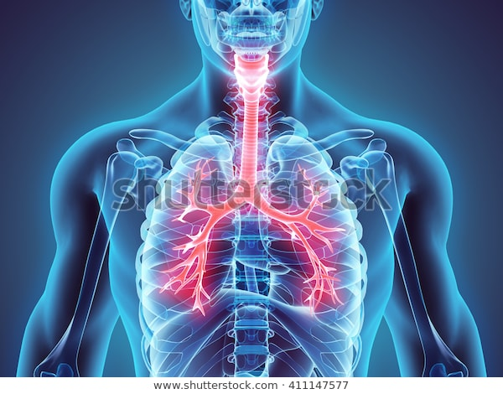
[Alt text goes here]
Respiratory system with the larynx, trachea and bronchi highlighted.

In this module you will explore aspects of health that reflect optimal and sub-optimal function of the lungs, the airways and oxygen delivery to tissues. You will develop an understanding of changes in respiratory physiology across the lifespan, including structural and physiological changes in health and disease. You will apply your knowledge and understanding to analyse case studies, both individually and with the assistance of your peers.

This module extends over two weeks. To maximise your learning, you should aim to systematically work through the each of the learning activities – whether they take place online (either in real-time or asynchronously) or in the face-to-face setting on campus. This module includes a mix of face-to-face and online learning activities including:

- online groupwork (2 x discussion forums and 1 x virtual tutorial)
- on campus 3-hour intensive during weeks 5 or 6 depending on your campus of enrolment
- a variety of interactive on-screen learning activities
- readings.

The main topics covered in this module are:

- respiratory dysfunction and failure
- chronic respiratory diseases, including asthma and chronic obstructive pulmonary disease (COPD)
- respiratory pharmacology.

Learning Outcomes
By the end of this module, you should be able to:
- explain the clinical manifestations (signs and symptoms) observed with alterations in respiratory function
- describe the aetiology and patho-physiological series of events which lead to alterations in respiratory health (including asthma and COPD)
- access and utilise respiratory disease management plans
- explain the rationale for common non-pharmacological and pharmacological management interventions to maintain respiratory health.

3.2 Respiratory anatomy and physiology knowledge

Test yourself
These are some topics that you may wish to revisit in readiness for this module:

- Respiratory tract and lungs (including the respiratory membrane).
- The movement of air into and out of the lungs during breathing (pulmonary ventilation).
- Homeostatic control of breathing.
- The movement of oxygen and carbon dioxide between the air and the blood flowing through the lungs (pulmonary gas exchange).
- Transport of oxygen and carbon dioxide in the blood.
- The movement of oxygen and carbon dioxide between the blood and the body's tissues (tissue gas exchange).

If you have previously studied and completed unit CXA243, you will have already covered this content, however, you may choose to work through this material as a refresher.

You can test your readiness to move on to the new material presented in this module by reviewing this module

Respiratory anatomy and physiology
Watch the following video and then completing the knowledge checks. If you are feeling confident that you remember the anatomy and physiology, then just skip the video and complete the questions to check your understanding of the path of air flow through the respiratory tract and the physiology of respiration. While it is not essential that you complete these revision activities, making time to learn this material (if you do not have prior knowledge in these topic areas) will ensure that you can understand and complete the learning activities in module 3 of this unit.
Media
Watch
Watch this short video to refresh your understanding of respiratory physiology. The presentation outlines the passageways that air flows through during breathing.
https://www.youtube.com/watch?v=qGiPZf7njqY&feature=youtu.be
Source: Khan Academy. 14 November 2012

Physiology of respiration
Try and answer the following questions to check your understanding in relation to respiration.
Please read each question carefully and consider all the options before selecting your answer. There is only one (1) correct answer for each question.
Interactive
Which of the following is the most important factor regulating rate and depth of breathing?
Response options | Feedback
*PaCO₂ | That’s correct.
PaO₂ | That’s not correct.
Cerebral cortex input | That’s not correct.
Diaphragm movement | That’s not correct.

Reference ranges for respiratory observations across the lifespan
Image
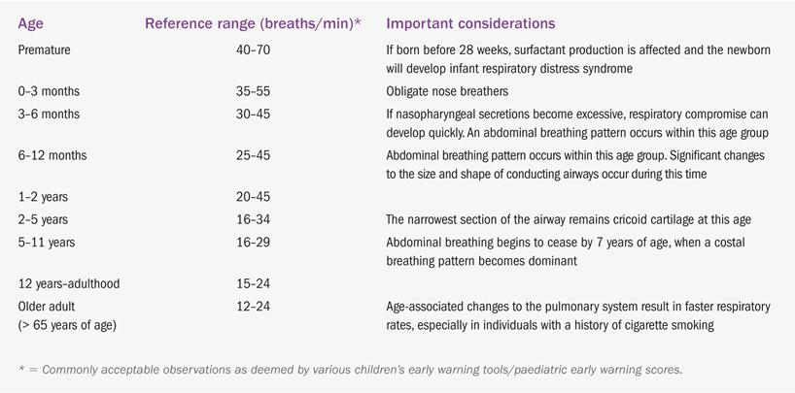
[Alt text]
Source: Bullock, S. and Hales, M. (2018). Principles of pathophysiology 2e, Pearson Education Australia.

References
Abramson, M., Frith, P., Yang, I., McDonald, C., Hancock, K., Jenkins, S., McDonald, V., Zwar, N., Maguire, G., Halcomb, E. and Polak Scowcroft, C., 2014. COPD-X Concise Guide for Primary Care. Brisbane. Lung Foundation Australia. https://copdx.org.au/wp-content/uploads/2015/08/LFA-COPD-X-doc_V3.02_0815_WEB.pdf

3.3 Optimising respiratory health for people and populations

Respiratory dysfunction and failure

Respiratory conditions affect the airways, including the lungs as well as the passages that transfer air from the mouth and nose into the lungs. They can be short term (acute) or long lasting (chronic) and can cause ill health, disability and death. This section will explore common clinical manifestations and causes of altered lung function along with management strategies that aim to avoid respiratory failure.

