Australian Lawyers Alliance
GPO Box 7052
Sydney NSW 2001
Professor Kate Warner
Director
Tasmanian Law Reform Institute
Private Bag 89
Hobart TAS 7001

28 June 2012

Dear Kate,
Australian Lawyers Alliance Response to Issues Paper No 17: Sexual Offences Against Young People
The Australian Lawyers Alliance (ALA) welcomes the opportunity to respond to the Institute’s discussion of what has become in Tasmania a politically and emotionally charged issue due to the circumstances surrounding the case of a 12 year old girl who was ‘prostituted’ by her parents to a number of males over the age of 18.
At the outset, it is important to note that the ALA’s members were and are as appalled as any other person would be about the sexual abuse which this young girl endured. However sensible and rational law reform is rarely achieved in a climate of outrage, fear or political grandstanding. The Commonwealth Parliament’s passing of various bills under the banner of anti-terrorism legislation is a case in point. These laws were formulated in the shadow of 9/11 and the Bali bombing and as a consequence, important safeguards and liberties were sacrificed because of the desire by political leaders to be seen to be ‘doing something’ about a perceived threat of terrorism.
The ALA has major concerns with the proposals for law reform in relation to sexual offences against young people, outlined in the Issues Paper. We question the ability of these proposals to ensure protection of the rights of an accused person facing a serious criminal charge and whether the proposed laws weaken the human rights of defendants in criminal trials.

The defence of mistake as to age
The Paper proposes that there be an age below which there can be no defence of consent or mistake as to age available to a person charged in relation to sexual activity with a child or young person.
The first question in response to this proposal is to ask, why is this necessary? The circumstances of the case involving the 12 year old girl were highly unusual. There is no evidence that defendants in criminal trials are utilising the defence of mistake as to age in relation to children or young people below the age of 15. We say 15 because there are some cases where a person might have thought that the young person with whom they participated in sexual activity was over the age of 17.
The defence of consent or mistake as to age are important defences available to persons charged with such offences. The utilisation of such defences in the courts includes the consideration of all evidence upon which the defendant relies. Submitting these defences is not a frivolous option for defendants.
If there is no evidence besides one usual case, then how can a stripping away of the rights of an accused person are justified? Particularly when, if found guilty of an offence that involves sexual activity with a person under the age of 17, the accused is likely to lose their liberty.
From a human rights protection perspective there can be no justification for amending the current law. In fact, given that Tasmania has ‘dropped the ball’ on developing a Human Rights Act, there is even more reason to ensure such protections are the guiding force in any discussion about the rights of the accused as opposed to those of the state.
This latter point was articulated neatly by the Supreme Court of Canada in R v Hess where Justice Wilson delivered the majority judgment. The case involved a Charter of Rights challenge to a law which provided that the defence of mistake as to age or consent was not available where the young person was under the age of 14. Justice Wilson observed that the vague potential benefits of such a law were outweighed by the possibly of life imprisonment for one who is mentally innocent, and decided in favour of the offender.
This is a compelling argument and particularly so when one considers that the public policy rationale in Tasmania for changing the existing law rests on one case alone.
The other argument against a change in the law is that a person who is charged with an offence involving sexual activity with a child or young person might be suffering from a mental illness at the time of offending, be acutely intoxicated or live with a disorder such as autism which means that while they might be fit to plead, they cannot be expected to be held to the same process of reasoning that one expects of the average person.
If intent or mistake is ruled out completely persons in the circumstances listed above would find themselves convicted of a serious crime and facing a loss of liberty despite their being genuine mistake and no intent on their part.
This runs contrary to bedrocks of the Australian legal system, including the presumption of innocence and access to a fair trial.
The removal of a defence essentially undermines the presumption of innocence of offenders in these situations; as such removal asserts from a public policy rationale that a person must be guilty in these instances.
Access to a fair trial is not simply secured by the judge’s ruling: it is also influenced by the availability of legal options for the defendant to plead that adequately reflects the state of mind of the individual at the time of the offence.
The need to clarify the existing law
We endorse the Institute’s view, set out in part 2 of the Paper, that the existing law, as set in the Criminal Code 1924 and the case law, as to the scope of defence of mistake as to age is unclear and needs clarification. In particular we endorse the view, expressed at 4.3.15 of the Paper that the scope of the defence remains to be clarified.
We support the approach whereby an accused person can combine the mistake as to age and consent defences. As the Paper notes, it is unclear in Tasmania whether or not the consent defence and general mistake defence in s14 of the Code can be combined, to allow a defence of mistaken belief as to the age of a young person in circumstances in which, if the belief were true, the conduct would be lawful.
To use the example the Paper puts at 2.2.3, we would argue that in a case where the accused is aged 19, the complainant is aged 14 but the accused thought that she was 15, the accused should be able to rely on the general mistake defence and the consent defence in s124 (3) (a) of the Code, noting that this latter defence is only available if the complainant is 15. To argue that an accused person ought not to have a defence available to him or her, without a compelling reason, is unfair.
One last observation. If there are to be changes to the law in respect of sexual assaults on children and young person’s such changes must clearly be prospective. Otherwise individuals are liable for a term of imprisonment because they had sexual contact with a person who was below the newly specified age. One cannot rely on the prosecutorial discretion of the DPP. With all due respect to the Director, he or she is only human and liable to make mistakes.
Conclusion
Ultimately, the rights of both offenders and victims of sexual offences must be protected. The availability of the courts to apply sentences that are appropriate to the offence committed and to fully consider the intent of the offender.
This is a balancing act that can at times, be complex, but must always be accompanied by rational, careful and considered discussion.
We would be happy to provide further comment on any of the issues we have raised within this submission.

Yours sincerely,
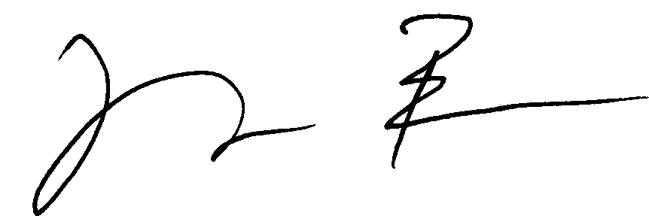

Greg Barns
National President
Australian Lawyers Alliance

(1990) 2 SCR 906.
Ibid para 33.

