Expression of Interest
Artist /Designer Brief
Palawa/Tasmanian Aboriginal Resources Database Project – University of Tasmania
Project Summary
Commission | Graphic design for the Palawa Resources Database
Client | College of Arts, Law and Education, University of Tasmania
Commissioner | Cultural Collections, University of Tasmania
Location | Intranet, University of Tasmania
Audience | Staff
Artwork budget | $500 mood board fee for short-selected artists/designers  + $2,500 for final artist/designer fee
Applications close | Tuesday 7 November 2023
Deadline for design | Tuesday 5 December 2023 (preliminary design) and January (final design)

Project Background
The University of Tasmania commenced an initiative to Indigenise curricula across Colleges and disciplines. A key component of this initiative is the implementation of the Palawa Resources Database. The database provides a centralised repository / portal for resources that Aboriginal people have contributed to, produced or created, underpinning efforts to incorporate Indigenous voices within teaching material.
Resources will be accessed through the Mukurtu (MOOK-oo-too) Content Management System. Each resource within the database has the potential to be accompanied by Community records relating to the resource and Traditional Knowledge (TK) Labels to assist users in culturally aware and appropriate use and acknowledgement of Aboriginal knowledges and experiences. Community records and cultural protocols are place- and context-specific and assist users to embed cultural competency in teaching practices. The Western bibliographic record, including copyright, appears alongside any additional cultural context.
Once established, the database will initially be implemented within the College of Arts, Law, and Education (CALE) and gradually be implemented across other Colleges within the University to assist in Indigenising the curriculum. The project is a strategic initiative co-led by the Office of Pro Vice Chancellor Aboriginal Leadership, College of Arts, Law, and Education, and the Library and Cultural Collections at the University of Tasmania.
Key ideas and purpose of commission
The University of Tasmania would like to commission a Tasmanian Aboriginal artist or designer to create a design that can be implemented into the Palawa Resources Database.
This commission is an opportunity for a Tasmanian Aboriginal artist or designer to create a design that recognises the rich and distinctive cultural heritage of Aboriginal Tasmania, past and present.
Artform
Tasmanian Aboriginal artists working in any artform that could be transferred and converted into a digital format are encouraged to apply for this commission. Additional support is available to pair the artist with a designer to assist in this conversion process.
For help with your application or more information about the commissioning process please contact Cindy Thomas, Graduate Indigenous Collections Officer, Library and Cultural Collections (contact details at end of document).
Design considerations
The artwork designs are for the Palawa Resources Database, which is an internal database to assist academic research and teaching staff at the University of Tasmania to diversify Aboriginal content within the curriculum. The design will need to reflect Tasmanian Aboriginal culture and heritage.
Artwork assets as deliverables include:
- Key graphic (banner) for home page
- Key graphic (smaller banner) for related tabs.
- Website header and footer
- Icon set for categories
- Icon set for various media
- Additional minor graphics in discussion with the team
Consideration regarding design:
- Design theme – an overall design that can be cropped to cover all areas of the database and provide uniformity

- Colour theme – complementary colours that can be utilised across the database and provide uniformity

- Refer to examples of other databases for consistency of theme, colour and design, including the resources in Appendix A
- Dimensions –
Banner 1920px x 700px for home page
Banner 1920px x 450px for related tabs

- Appropriate cultural protocols
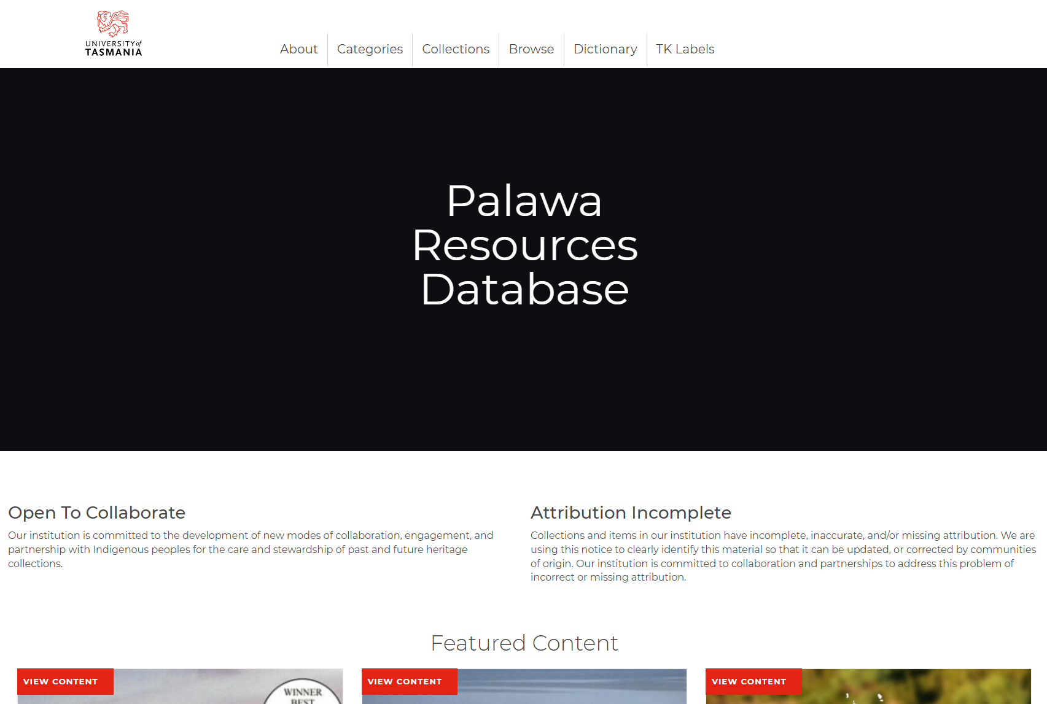
Figure 1- Palawa Resources Database ‘Home’ page showing larger banner requiring design customisation.
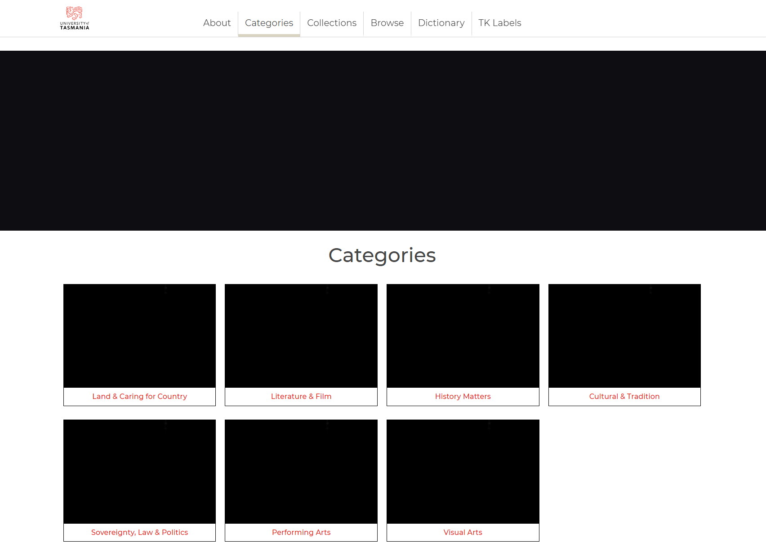
Figure 2-Palawa Resources Database ‘Categories’ page with smaller banner and resource categories requiring design customisation.

Selection process and eligibility
The Selection Committee will consider all eligible applications and select an artist on the strength of their support material showing examples of their art practice with reference to the Selection Criteria.
After considering the applications, the Selection Committee will develop a shortlist and request an interview with selected artists to discuss the submission in more detail and request a mood board of designs prior to the final selection. The mood board designs will attract a fee of $500. The final fee for the selected artist will be $2,500.

Emerging or first-time Tasmanian Aboriginal artists and designers are strongly encouraged to apply.

If you are unsure about your eligibility, more information is available at:
Department of Premier and Cabinet (dpac.tas.gov.au)
Selection criteria
1. Suitability
To what extent is the concept and response culturally appropriate? To what extent do the artistic concept, design, materials and delivery method address the brief?
2. Viability
How feasible is the project given the commission budget, constraints and timelines?
3. Capability
To what extent does the team demonstrate the necessary skills and experience to deliver the commission?
4. Vision
How well does the proposal demonstrate a creative or innovative vision in terms of concept, media, construction methods, materials and/or collaborations?
Selection committee
Library and Cultural Collections, University of Tasmania | Caine Chennatt, Director Curatorial and Cultural Collections, Cultural Collections  Cindy Thomas, Graduate Indigenous Collections Officer, Cultural Collections
College of Arts, Law and Education, University of Tasmania | Denise Robinson, Indigenous Fellow Creative Arts, Creative Arts and Media
Applicants wishing to clarify information regarding the commission should contact Cultural Collections, not other members of the Selection Committee.

Timeline
The Artist’s Brief will be advertised Wednesday 18 October 2023. The closing date for applications is Tuesday 7 November 2023. Applications must be completed and lodged online by 11:59pm on the closing date. Support material must be uploaded as part of your application and will not be accepted separately.
Artists will need to present their preliminary designs Tuesday 5 December 2023. The proposed deadline for the delivery of the final design files will be in January 2024. Exact dates will be negotiated with the artist and stakeholders.
Marketing material
Images of the artwork will be included in online/digital promotional and marketing material for the University of Tasmania. The artist and details of the artwork will be properly acknowledged on all material.
Budget
The artwork budget is intended to cover all costs associated with the design of the artwork and creation of high-quality TIFF or AI (Illustrator) files for production. If you are bound by an exclusive contract to a commercial gallery, it is your responsibility to notify the gallery and negotiate commission fees which may require payment.
- EOI stage: No fee, receiving portfolios only
- Short-selected artists: $500.00 for mood board of designs
- Final selected artist: $2,500 for designs
Additional support is available for transfer artwork into functional designs. This will be in discussion with the artists as they progress.
Applications
Applications consist of:
• applicant’s contact details
• a maximum 250-word description of the artist’s skills, experience, and interests. First-time artists and designers are encouraged to apply.
• portfolio with example material which gives the selection panel an indication of the artist's design styles, previous artwork, concepts or rough designs.

Artists are encouraged to discuss their applications with the Director or Graduate Indigenous Collections Officer, Cultural Collections, before submission.
Applications will be received via email to cultural.collections@utas.edu.au or via post Private Bag 25, Hobart 7001 Tasmania.

Enquiries

Cindy Thomas | Caine Chennatt
Graduate Indigenous Collections Officer, Cultural Collections | Director,  Curatorial and Cultural Collections
University of Tasmania | University of Tasmania
Ph: (03) 6324 5047 | Ph: (03) 6226 2223
Cindy.Thomas@utas.edu.au | Caine.Chennatt@utas.edu.au

APPENDIX A
Summary of the commissioning process
- Brief advertised (Graduate Indigenous Collections Officer, Cultural Collections available for information about application development).
- Expression of interest received.
- Selection Committee meets to select artist for commission OR shortlists a selected number of artists.
- If a shortlist is compiled, shortlisted artists present mood boards to the Selection Committee.
- Artist contracted.
- Artist develops preliminary designs.
- The preliminary designs are presented for consideration by relevant stakeholders.
- The designs are approved and permission to proceed with final design files received.
- Files reviewed and artist notified of any outstanding issues to be addressed.
- Artist resolves any identified issues.
- Acceptance of commission upon successful hand over by relevant stakeholders.
- Artist receives final payment.
- Evaluation of the project.
Resources
The following website provides further information about Mukurtu:
- https://mukurtu.org/about/
The following websites contain examples of projects using Mukurtu:
- Passamaquoddy People - https://passamaquoddypeople.com/
- Plateau Peoples - https://plateauportal.libraries.wsu.edu/
- State Library of New South Wales - https://gather.sl.nsw.gov.au/
- Wurrppujinta Anyul Mappu - Wumpurrarni-kari | A Gathering Place (wsu.edu)
Mukurtu West - Browse by Category | Mukurtu West (wsu.edu)

